

HIMALAYA COLLEGE OF ENGINEERING

Advanced C++ Programming Lab Report
Lab 1: Quadratic Equations, Triangle Classification and Password Strength Checking

Prepared By: Krrish Nyoupane
Subject: Object Oriented Programming (OOP)
Program: Bachelors of Electronics and Computer Engineering
Institution: Himalaya College of Engineering
Date: May 25, 2025
Objectives:
- To utilize control structures, functions, and built-in libraries in C++ programming.
- To perform calculations involving quadratic equations using the standard formula.
- To implement logic that checks if a triangle is valid and determines its type.
- To use string manipulation and character analysis for evaluating password strength.

Tools and Libraries Used:
- Programming Language: C++
- IDE: G++
- Libraries: #include <iostream>, include <string>, #include <math>

Theory:
Basics of C++ Programming
C++ is a versatile language used to build efficient programs. Beginners start by learning variables, conditional statements, and loops to solve simple problems.

Structure of a C++ Program
A basic C++ program includes header files (like <iostream>) and starts with main(), which is the entry point. The program uses using namespace std; to access standard features easily. The main function contains the code and ends with return 0; to indicate success.

Example:

- #include<iostream>
- using namespace std;
- int main() {
- cout << "Hello world!";
- return 0;
- }

Variables and Data Types
Variables store data. You can declare and assign them like this:

- int age; // Declaration
- age = 20; // Assignment
- int score = 100; // Declaration + Initialization

Common Data Types:
- int – whole numbers (e.g., int x = 5;)
- float – decimal numbers (e.g., float pi = 3.14;)
- double – more precise decimals (e.g., double d = 2.718;)
- char – single characters (e.g., char c = 'A';)

Variable Naming Rules
- Start with a letter or underscore
- No digits at the beginning
- No space or special characters (except _)
- Case-sensitive (Age ≠ age)

Conditional Statements
Conditional statements control program flow based on conditions.
if statement:
Used when we must check the condition.
Syntax:
  - if (condition) {
  - // Code runs if condition is true
  - }

if...else statement:
Used when we must check the condition and execute true and false condition separately.
Syntax:
- if (condition) {
- // Runs if true
- } else {
- // Runs if false
- }

else….if ladder:
Used when multiple conditions are to be checked one after another.
Syntax:
- if (condition1) {
- // code if condition1 is true
- } else if (condition2) {
- // code if condition2 is true
- } else if (condition3) {
- // code if condition3 is true
- } else {
- // code if none are true
- }

switch Statement:
Used to select one block of code from many options based on a variable's value.
Syntax:
- switch (expression) {
- case value1:
- // code for case 1
- break;
- case value2:
- // code for case 2
- break;
- ...
- default:
- // code if no cases match
- }

Loops in C++
for Loop
Used when the number of iterations is known.
Syntax:
- for (initialization; condition; update) {
- // code to repeat
- }

while Loop
Used when the condition is checked before the loop body and the number of repetitions is not fixed.
Syntax:
- while (condition) {
- // code to repeat
- }

do...while Loop
Runs the loop body at least once before checking the condition.
Syntax:
- do {
- // code to repeat
- } while (condition);

Lab Questions:
Q no 1: Solve $a^{2}+bx+c=0$ and handle all discriminant cases.
Code:
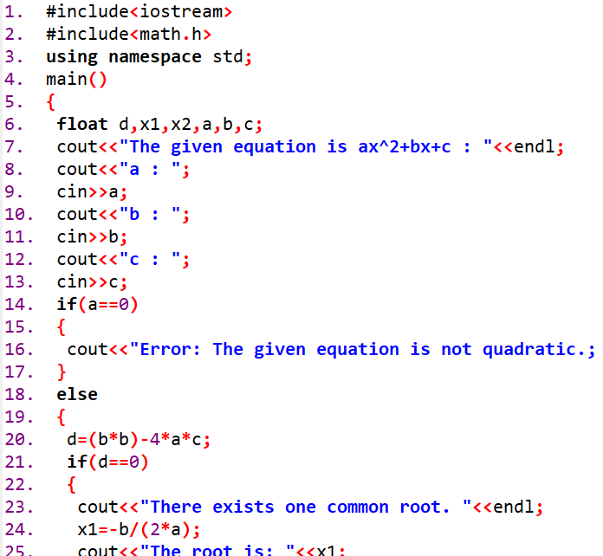
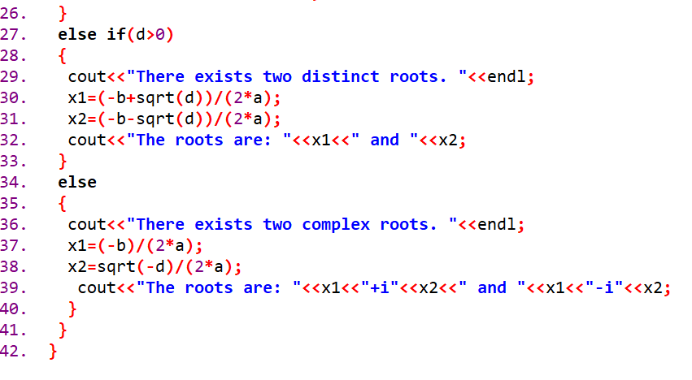
Output:
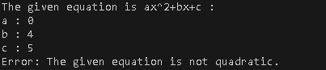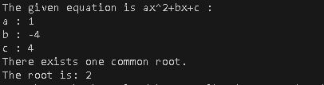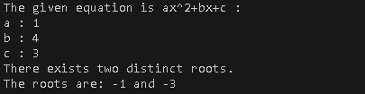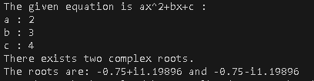
Q no 2: Check if three angles form a triangle and classify it.
Code:

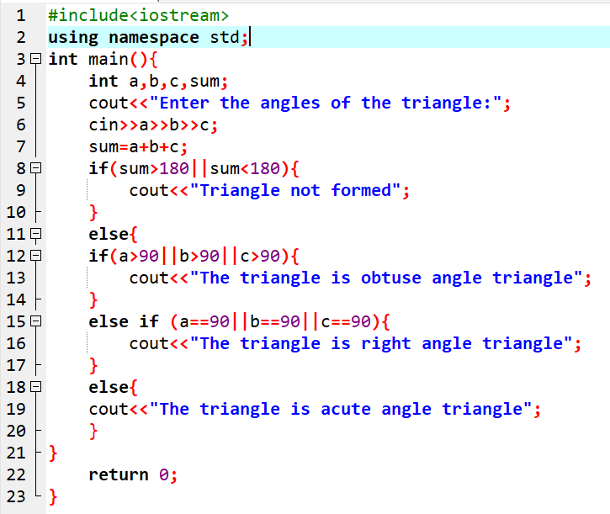
Output:
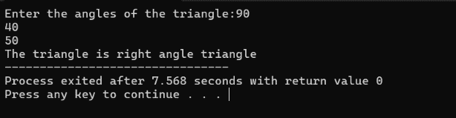
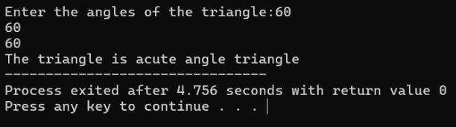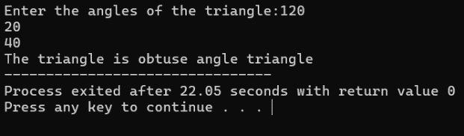
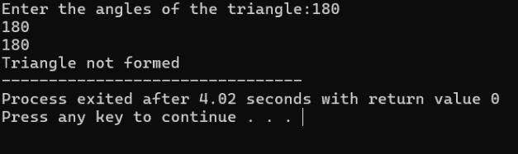

Q no 3: Check password strength based on length and character rules.
Code:

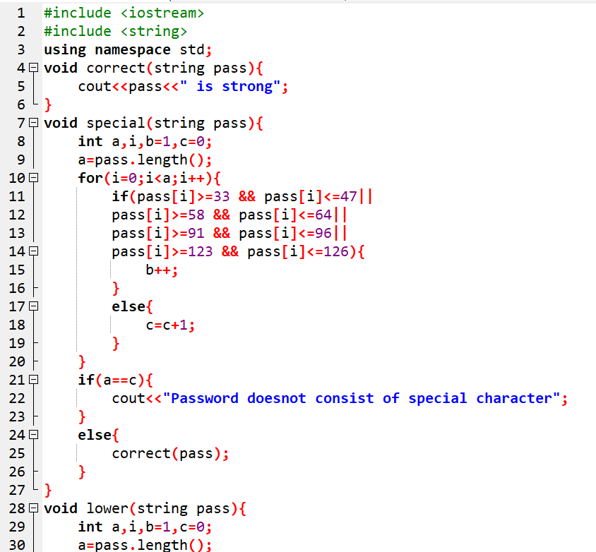
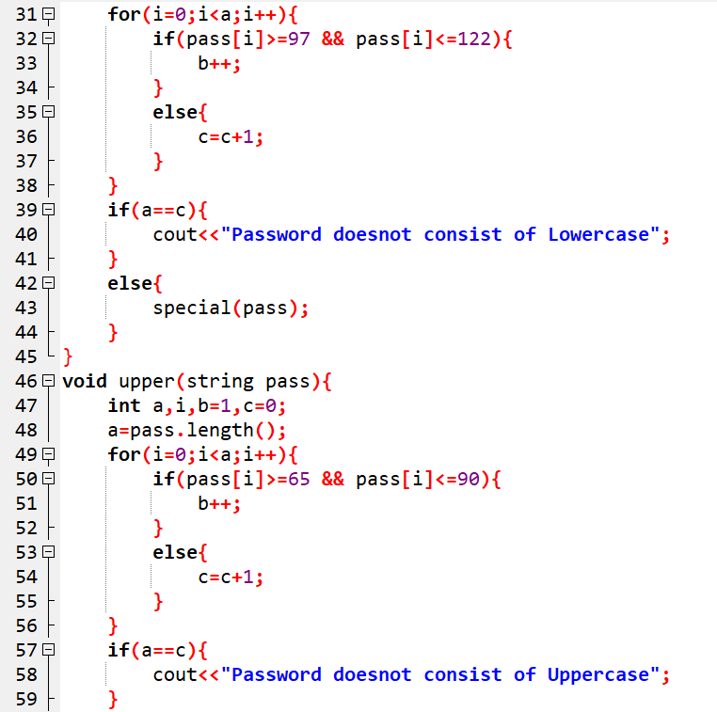

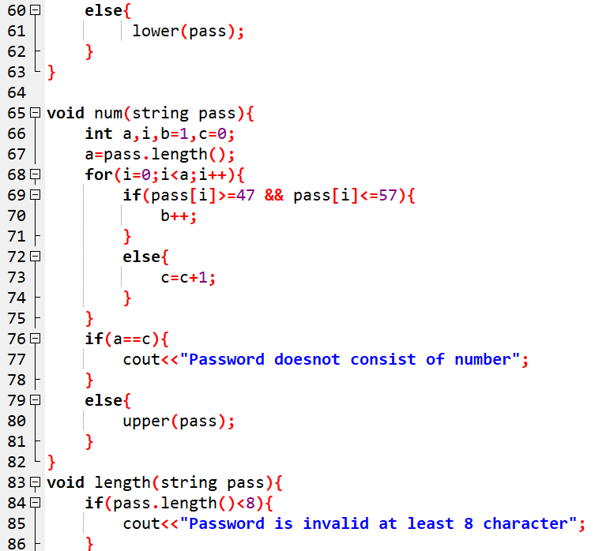
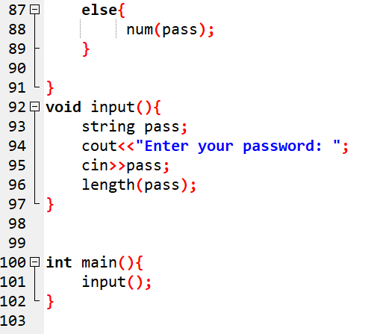

Output:
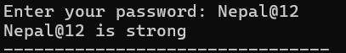

Conclusion:
In this lab, we explored essential C++ concepts by tackling various practical problems. The focus was on utilizing control structures, functions, and string manipulation methods. This practical approach lays a strong foundation for progressing to more advanced subjects, such as C++ development and object-oriented programming.

